A PROJECT REPORT ON

ONLINE CRAFT MANAGEMENT SYSTEM

Submitted in partial fulfilment of B.Sc. 6th Semester

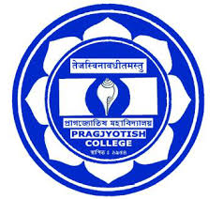

Submitted by

**INDRANI DAS**

**CODE: S-16032 ROLL NO. 0273**

**REGISTRATION NUMBER: 251564 OF 2016-17**



Under the Guidance of

Dr. Masih Saikia

Head of The Department

Department of Computer Science

Pragjyotish College